Lunch an EC2 instance and Associate and Elastic IP Later
Lunch the EC2 Instance Using the instance name and Instance AMI.
- Click on Lunch Instance
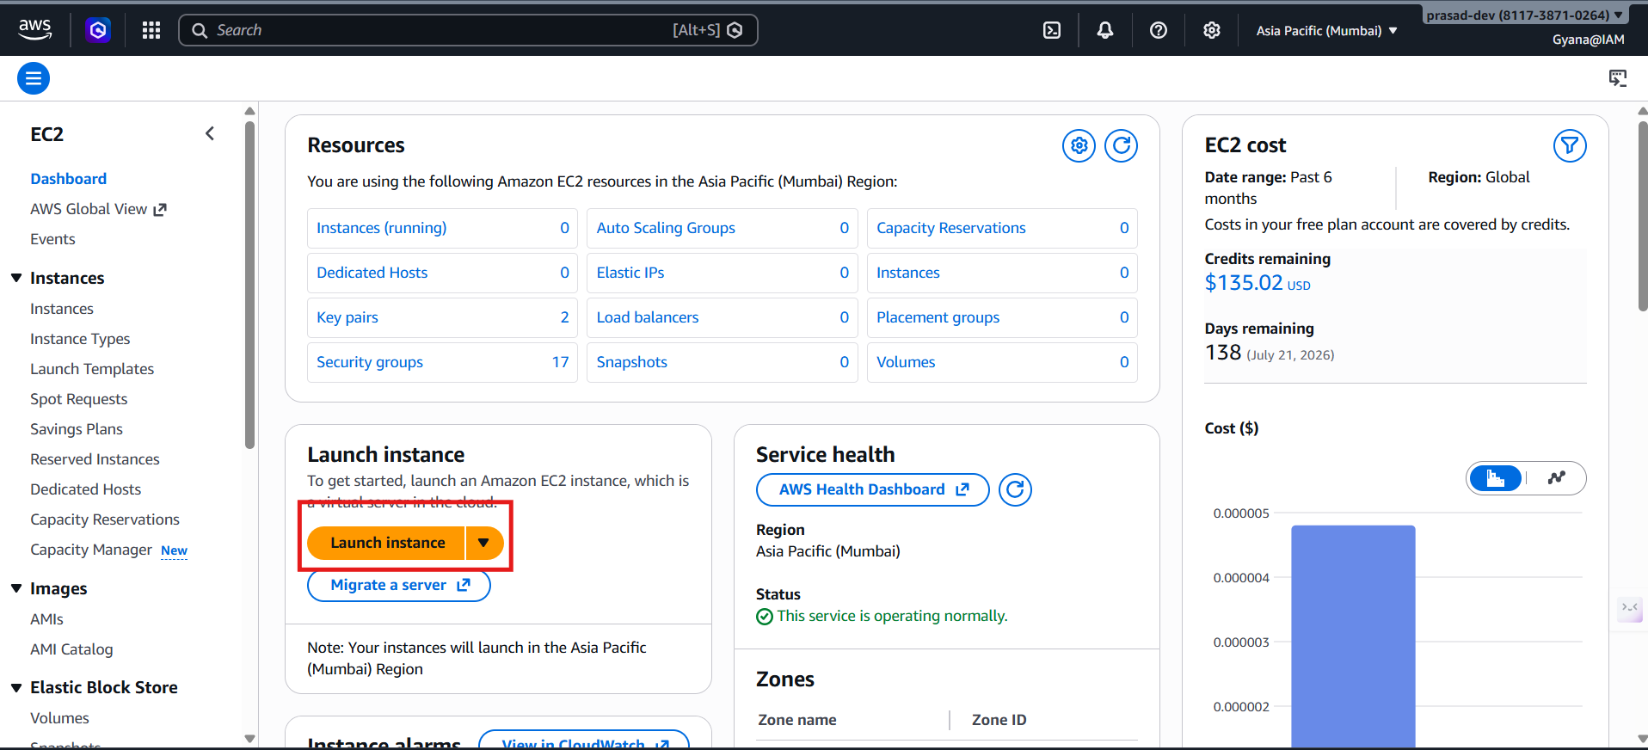
- Give the name and use Amazon Linux also can use any type of AMI.

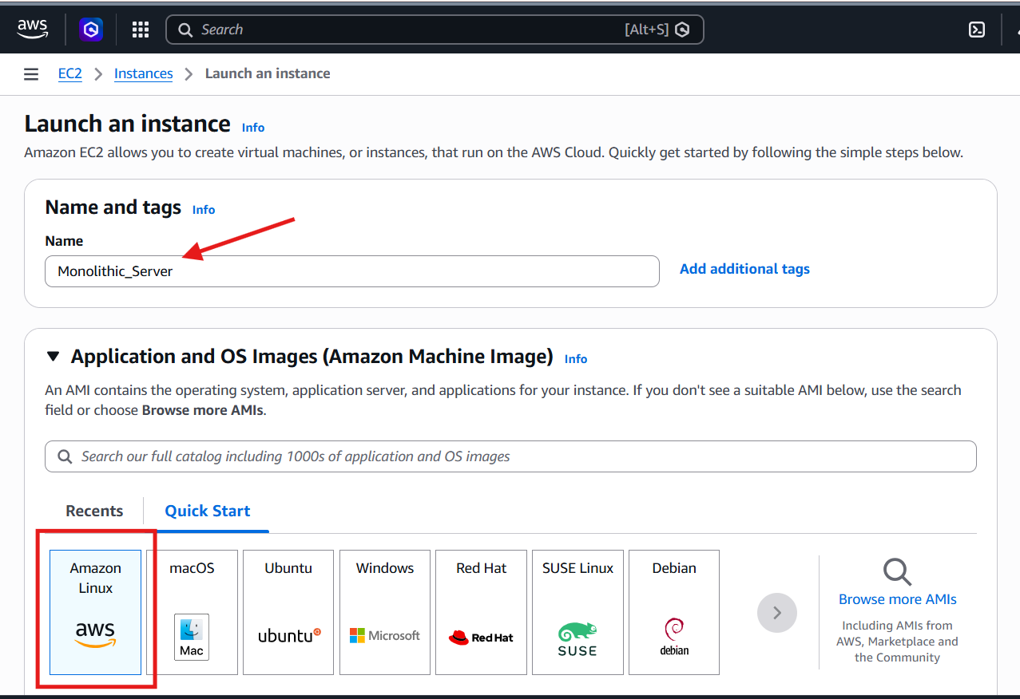

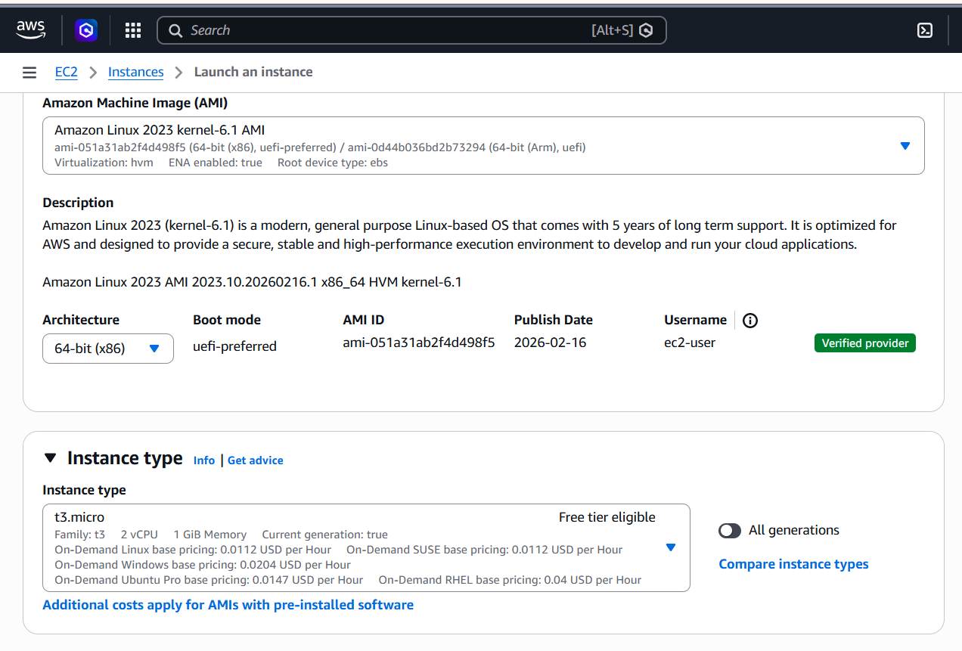
- Use the Private Key
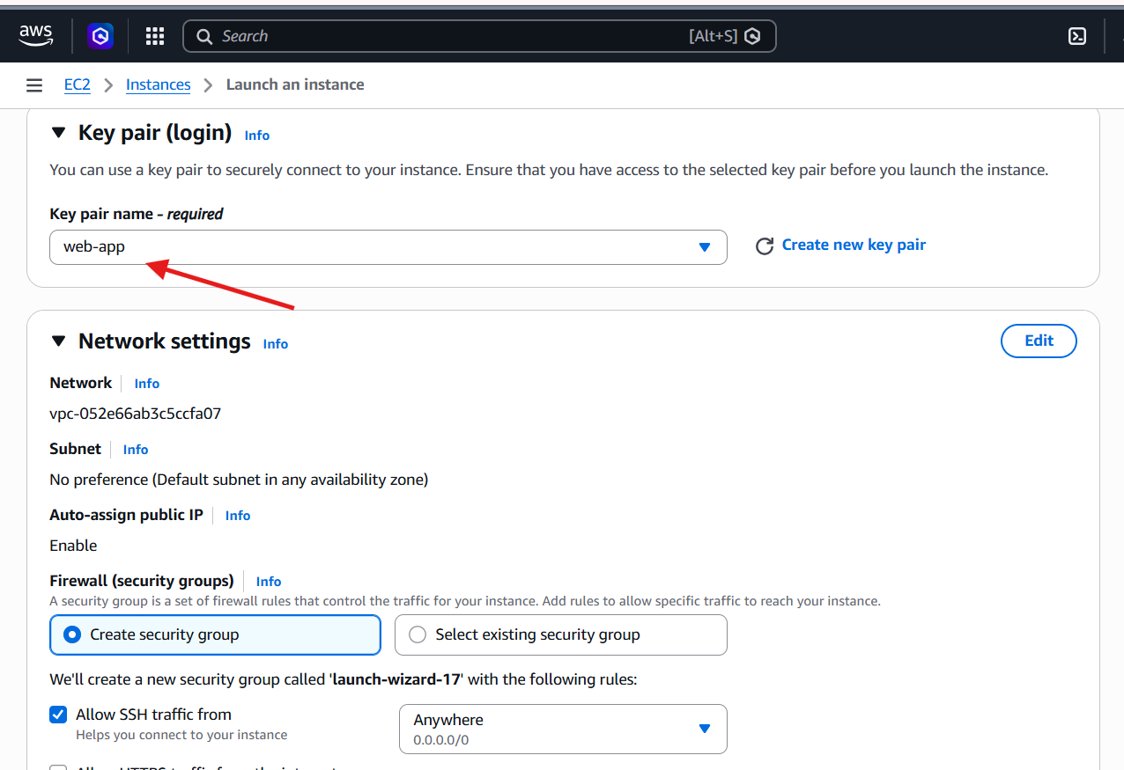
Allow the HTTP traffic from the internet.
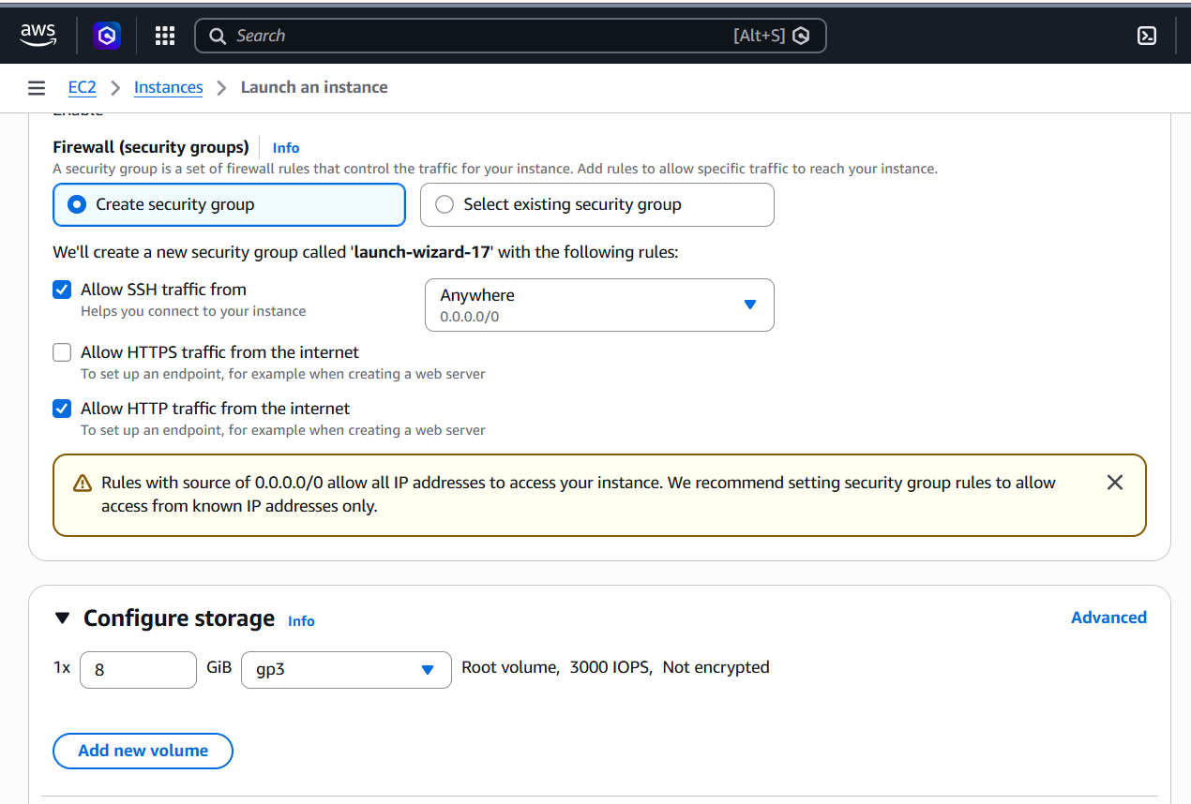
- Lunch the instance.
- After lunching the instance select Elastic Ips.

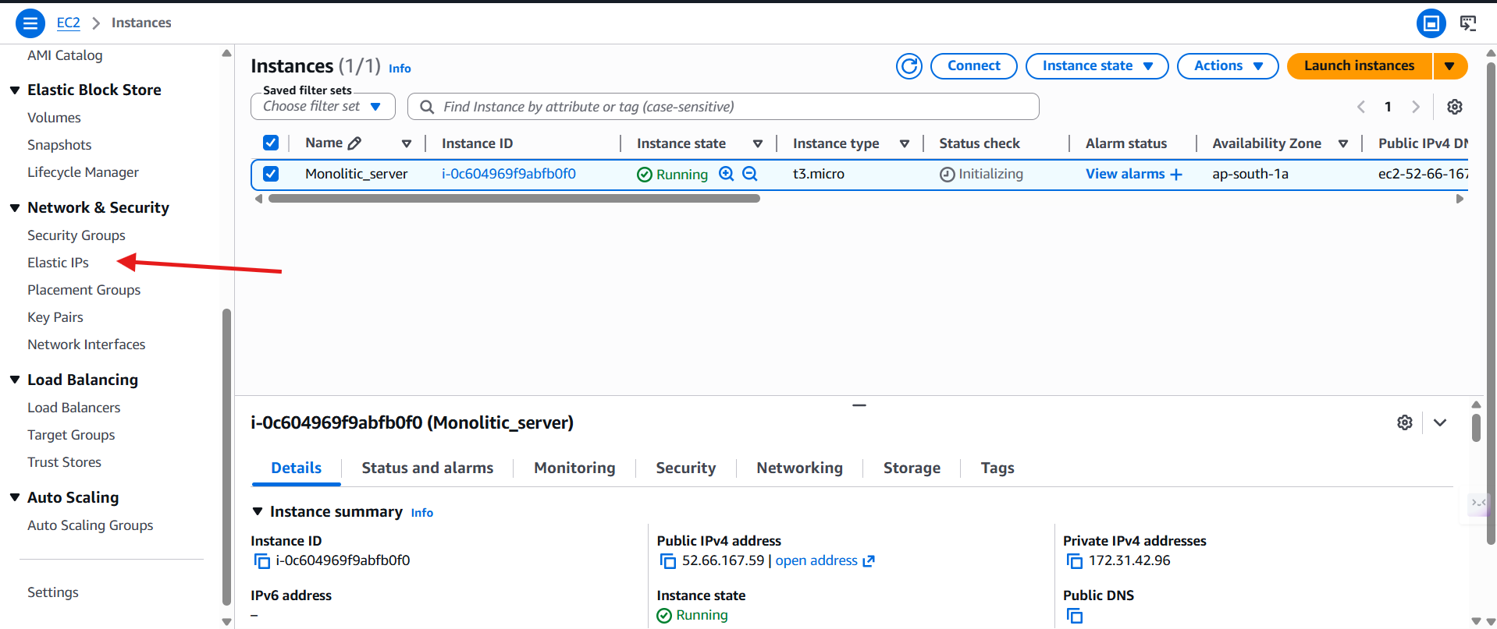

- Click on Elastic IP address.
- Click on Allocate Elastic IP address.
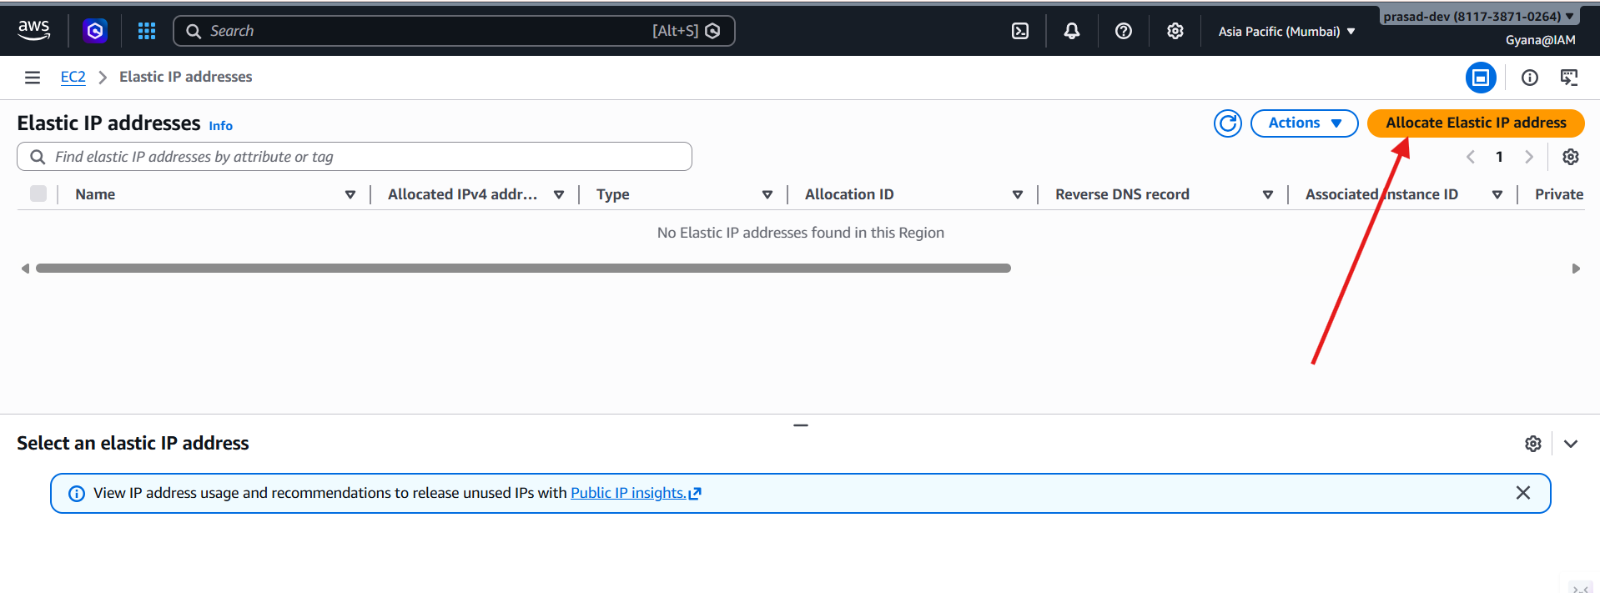
- Now give the region in which the EC2 instance is running.
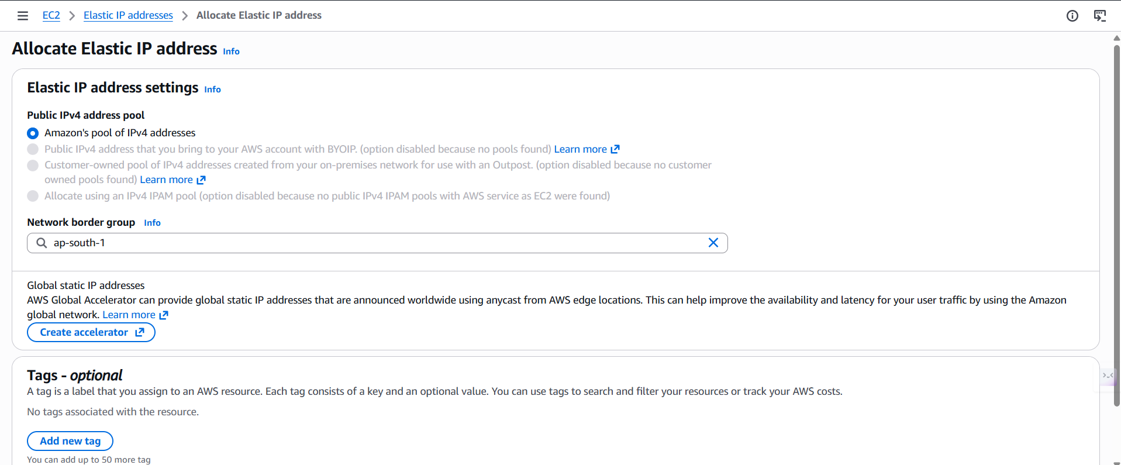
- Click on allocate to create an Elastic IP.
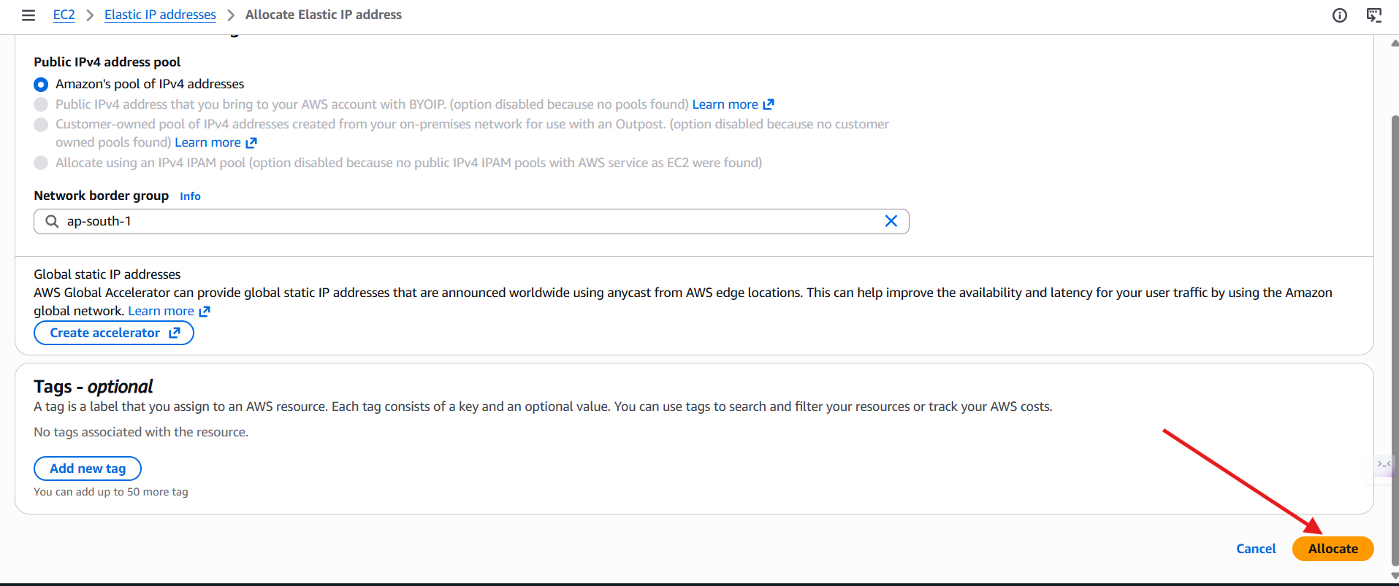

- Click on action to open the options.
- Click on Associate Elastic IP address
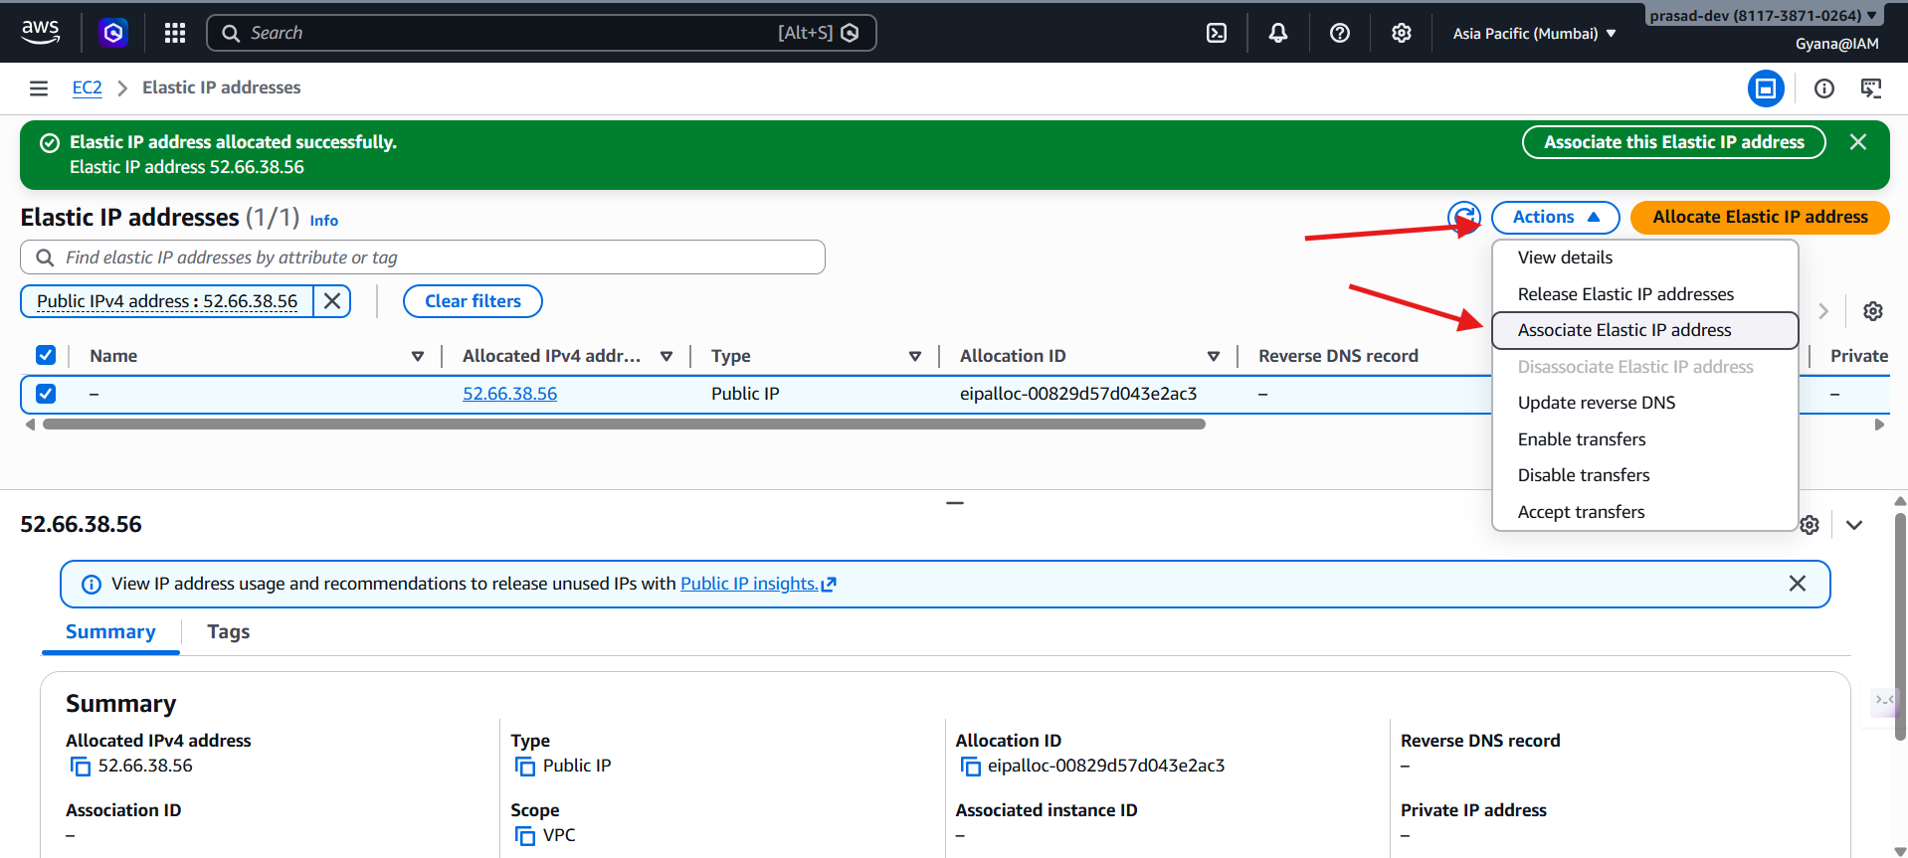
- Now give the EC2 instance which instance to allocate.
- Also give that EC2 instance private IP.
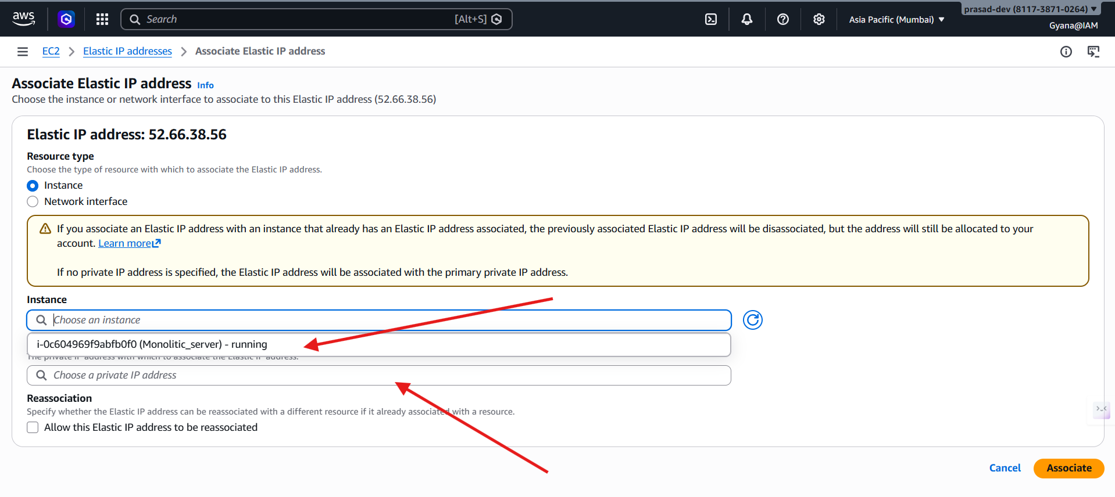
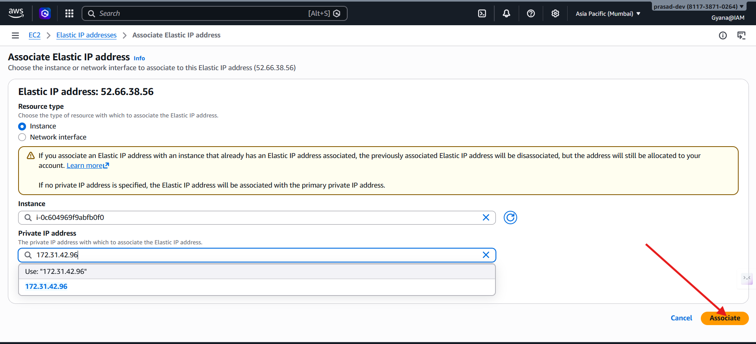
- Public IP associated successfully.

